**Project Design Phase-II**

**Data Flow Diagram & User Stories**

|  |  |
| --- | --- |
| Date | 20 July 2025 |
| Team ID | LTVIP2025TMID41443 |
| Project Name | Transfer Learning-Based Classification of Poultry Diseases for Enhanced Health Management |
| Maximum Marks | 4 Marks |

**Data Flow Diagrams:**

A Data Flow Diagram (DFD) is a traditional visual representation of the information flows within a system. A neat and clear DFD can depict the right amount of the system requirement graphically. It shows how data enters and leaves the system, what changes the information, and where data is stored.

**Example:** [**(Simplified)**](https://developer.ibm.com/patterns/visualize-unstructured-text/)

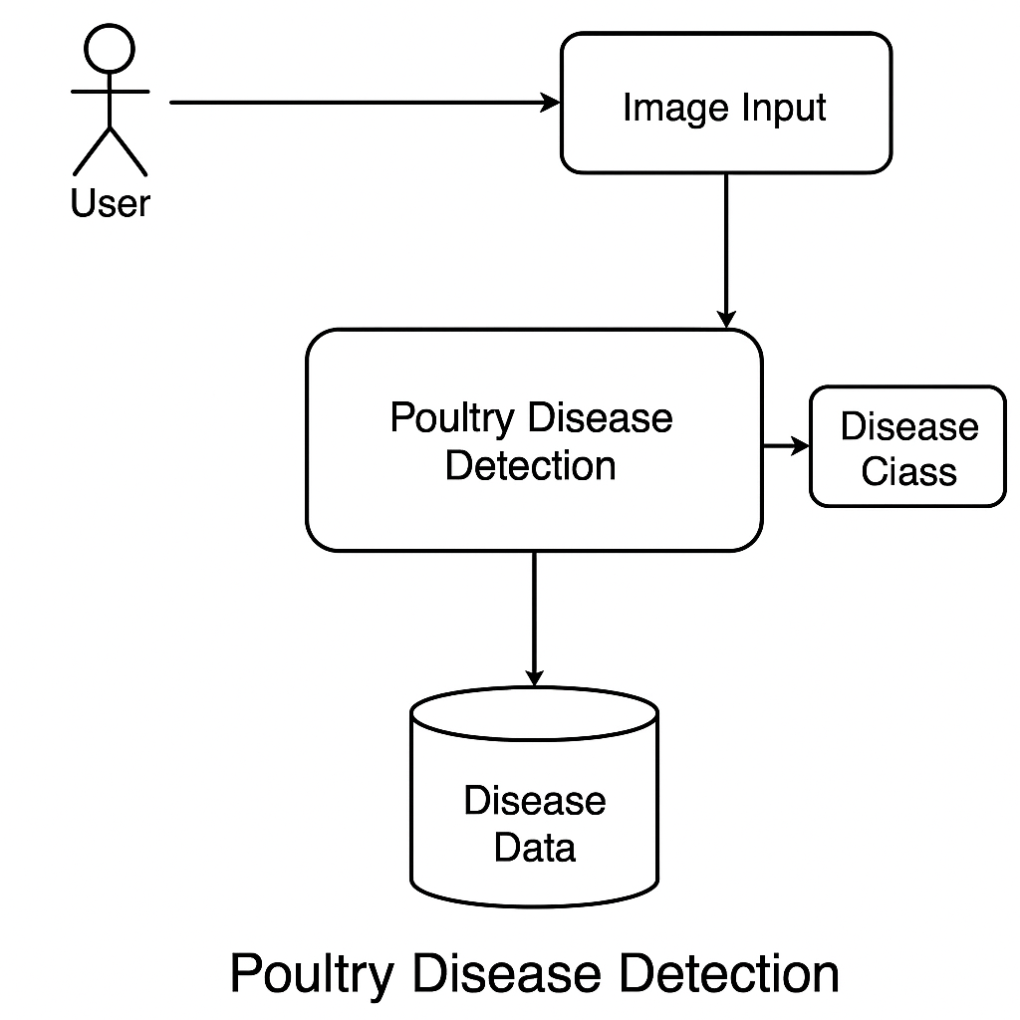

**User Stories**

Use the below template to list all the user stories for the product.

| **User Type** | **Functional Requirement (Epic)** | **User Story Number** | **User Story / Task** | **Acceptance criteria** | **Priority** | **Release** |
| --- | --- | --- | --- | --- | --- | --- |
| Customer (Mobile user) | Registration | USN-1 | As a user, I can register for the application by entering my email, password, and confirming my password. | I can access my account / dashboard | High | Sprint-1 |
|  |  | USN-2 | As a user, I will receive confirmation email once I have registered for the application | I can receive confirmation email & click confirm | High | Sprint-1 |
|  |  | USN-3 | As a user, I can register for the application through Facebook | I can register & access the dashboard with Facebook Login | Low | Sprint-2 |
|  |  | USN-4 | As a user, I can register for the application through Gmail | I can register using Gmail login | Medium | Sprint-1 |
|  | Login | USN-5 | As a user, I can log into the application by entering email & password | Successful login redirects me to dashboard | High | Sprint-1 |
|  | Dashboard | USN-6 | As a user, I can upload an image of my poultry to get disease detection results. | App shows prediction result after upload | High | Sprint-2 |
| Customer (Web user) |  | USN-7 | As a user, I can access the web dashboard to upload chicken images and view results. | Upload option and disease result appear after login | High | Sprint-2 |
| Customer Care Executive |  | USN-8 | As support, I can view all submitted disease cases and assist the farmer accordingly. | Case details load in admin view with contact info | Medium | Sprint-2 |
| Administrator |  | USN-9 | As admin, I can view, block, or delete suspicious accounts from the database. | Admin panel shows user list with actions | High | Sprint-3 |
|  |  |  |  |  |  |  |
|  |  |  |  |  |  |  |
|  |  |  |  |  |  |  |